Anglia Network Europe

What factors lead to the successful expansion of Anglia Network in Ukraine

Illya Kaynov

Research Proposal
Student name | Illya Kaynov
ASIS student number | 2074616
ASIS mentor | Grainne Gaffney
ASIS Programme | IBMS
Double Degree University Name | Budapest Business School
Double Degree University Student number | B759PG
Double Degree University Mentor | Józsa László
Date | 10.06.2015
Version | Final

logo of Double Degree University
remove if not applicable

Executive summary
In the modern world of communication, English language has become one of the most important means of cross-cultural communication. From the time of its creation, Anglia Network Europe seeks the opportunity to help people, to give them access to better English education. The company has been connecting teachers and students together for 19 years, to allocate new opportunities and ways to learn English. The network has grown considerably in past years, and now connects 350 schools in the Netherlands. Throughout its history, the company based its business on approach that is effective in the Dutch system. However, when it comes to international expansion, new approach and marketing strategy should be developed in order to achieve success.
The research shows all steps that Anglia Network Europe should undertake in order to expand into the Ukrainian market. Desk research helped to determine target locations and type of customers. The aim of this research is to complement already existing knowledge with newly developed approach that will help to extend the network and provide Anglia with loyal customers. Taking into consideration the unique layout of the company and features of its clientele, relationship marketing strategy has been applied. This approach implies developing long-lasting relationship with clients, understanding their needs and providing best option for the cooperation.
Field research has provided useful data that was used to define the key critical points of Anglia expansion in the Ukrainian market. The main independent variable, the adaptation of the services to the local market, was analysed by the mean of focus group. During the research, the project objective was achieved. Thus, this paper identifies the main factors that would eventually lead to the successful expansion of Anglia Network Europe in Ukraine.

Key words: English, network, expansion, marketing, Ukraine

Contents
1. Project Objective 4
2. Exploration 6
2.1 Situational Analysis 6
2.1.1 History of Anglia Network Europe 6
2.1.2 Current Development of Anglia Network Europe 7
2.1.3 Situation in Ukraine 8
2.1.4 Competition analysis 10
2.2 Theoretical Background 11
3. Conceptual Model 13
4. Proposed Solution 15
5. Methodology 16
5.1 Sampling 18
6. Analysis 19
7. Conclusion 21
7.1 Limitations 23
8. Recommendations 25
9. Bibliography 26
10. Appendices 28
10.1 Appendix #1: Questionnaire 28
10.2 Appendix #2: The results from the questionnaires 30
10.3 Appendix #3: Coding of the Focus Groups 35

Project Objective
In the modern world of globalization and rapid technological development, communication skills and English language in particular have become extremely important (2013). English has become the dominant business language and it is almost a necessity nowadays for people to speak it if they are to enter a global workforce. According to Ethnologue statistics (Lewis, 2015), English is the official language in sixty countries and is being spoken as primary and secondary by nearly 840 million people. Moreover, large share of the world’s films, books and music, as well as more than 55% of the content produced on the Internet is in English (The World Factbook - Languages, 2010). Therefore, by learning English people can get access to great wealth of information and entertainment. All of the above elements make English one of the most important languages in the world, which provides numerous opportunities for personal and professional self-actualization.
Anglia Network Europe is a network that specialized on assessing and improving English proficiency. Its core objective is to improve and structure learning and teaching of English language. The organisation is primarily focused on providing examinations, which cover ten levels of English proficiency and have been internationally recognised for its professional competence. Moreover, the network design enables English learners to find and help each other by providing a platform that connects schools, colleges and universities. This gives students an opportunity to receive high quality English education on international level.
Altogether, Anglia provides exams, summer schools, teacher training, English courses, lesson materials and have a structured programme for international projects. However, due to inability to transfer few of the activities abroad, this research will concern only international projects, summer schools and exams.
International projects based on the idea of connecting students from different countries and schools in order to practice English via online conversations or in form of email. This allows making a step from regular school programme and giving learners additional opportunity to develop their communication skills. In addition, summer schools provide a similar technique as peer-to-peer communication, but in a form of a five-day programme that requires participants to work together. Thus, students are encouraged to learn from each other and use English in action. In both cases, quality and number of potential projects and summer schools are highly dependent on the size of the network and presence of international members. Moreover, based on the theory, enlargement of a network helps to provide more learning opportunities for students and attract more participants in the future. According to Kathie Head (2007), the size of the network has a positive effect on people’s attitude, and, consequently, makes the organisation more attractive for potential customer (Head, 2007).
The network’s administration chose three countries for Anglia expansion in 2015: Ukraine, Germany and Belgium. Germany and Belgium were chosen, because their educational systems are similar to the Dutch. This makes it possible to apply the existing approach that has been used in the Netherlands for over 19 years. On the contrary, Ukraine was chosen as a country that have different social and cultural background, but still presents considerable potential for future network expansion. Throughout the past several years Ukrainian society has become more European oriented and thus the demand for English education has grown significantly. Moreover, Anglia has past experience with organising projects in the city of Kharkiv, such as summer schools and students training.
Due to the fact that Anglia Network Europe has no experience in expanding in foreign countries, new members (Illya Kaynov, Gloria Iurato, and Katarina Kilibarda) were hired to form the European Expansion team. The team is responsible for conducting in-depth analysis of the foreign markets and draw opportunities and possibilities for Anglia to expand its activities. Therefore, this paper will focus on expansion in Ukraine, one of the three chosen countries, and will cover all steps of the process. Accordingly, the research question can be formulated as following:
What factors lead to the successful expansion of Anglia Network in the Ukrainian education system?
The answer to this question will provide us with information regarding the most important aspects that need to be considered in order to prepare a detailed plan. The knowledge gained by the end of the research will be used to obtain new contacts and members of the network, resulting in increase in the number of active participants. L’viv, Uzhorod and Ivano-Frankivsk, are chosen as target cities for Anglia Expansion.

Exploration

2.1 Situational Analysis

2.1.1 History of Anglia Network Europe
Anglia Network Europe was founded by Arnold Augustijn in 1996 as a part of franchise agreement with Anglia Examinations, whose headquarter is located in Chichester, England. Initially, the franchise contract included one of the University College from ROC West Brabant network as a main representative in Europe. A few teachers were responsible for providing examinations to the students in the Netherlands. At that time, the only service that they provided was exams. Thus, no marketing strategy was employed and the company was fully dependant on word-of-mouth recommendations.
Demand on examinations was incrementally increasing from year to year and more exam participants expressed interest in preparation activities. Hence, in 1999 administration of the network decided to organise meeting for all members to discuss and develop a new plan in order to meet customers’ demand. Consequently, the idea of organising summer schools was formed, with the first summer school held in 2004. Moreover, a platform that connects schools, students and teachers was established, in order to facilitate various projects and activities. This new concept provided learners with different approach for studying English, called “English in Action”.
The new platform resulted in creation of a network of educational institutions all over the Netherlands. Essential factors such as recognition of the importance of English, high motivation and willingness to study coupled with an enthusiastic group of teachers contributed to this innovative system and network extension.
After 17 years of successful operations, Anglia Network Europe had become too large to maintain inside University College. Therefore, in 2013 it separated from the ROC West Brabant and became an independent company under reviewed franchise agreement with Anglia Examinations England. The new status granted the company with possibilities of expansion to the foreign countries.

2.1.2 Current Development of Anglia Network Europe
Throughout the years, Anglia Network Europe has enlarged its businesses from providing examinations to approximately 20 people in 1996 to 20,000 in 2014. Furthermore, the company has shown a significant growth in terms of numbers of active participants, which is considered to be students and teachers that organise and take part in various projects and activities. At present, Anglia Network Europe work with teachers in approximately 138 primary schools, 174 secondary schools and 15 other schools (Annual Report Anglia Network Europe, 2013).
From the time of its independence, Anglia Network Europe has been considering the expansion in other European countries. However, so far, the company has not developed an adequate marketing plan or strategy to enter a foreign market, as the primary focus was on building a stable network for Dutch customers.
The approach Anglia Network Europe has been using in the Netherlands is based on peer-to-peer relations between teachers from various schools. This implies that when the company reaches a specific school, teachers would contact fellow colleagues from other institutes who might be interested in the services offered; consequently, providing more students with access to English education. Regarding its marketing strategy, the network uses elements of relationship marketing, meaning that relationships with customers, their retention and loyalty is in the focus. The success of this strategy can be explained by the fact that connections with clients and the company recognition is relatively strong in the Netherlands.
Apart from the examinations, which are fully controlled by the headquarters in Chichester, all other Anglia Network Europe activities are flexible and rather adaptable. Company always maintain friendly relations with its customers and use personal approach to understand their needs. Every new school that would like to take part in one of the activities is bringing new experience to the company. For example one of the Christian schools was interested in Anglia’s Summer Schools, but according to their beliefs, they could not accept the regular programme. After discussion, the company decided to adapt existing programme to match the requirements (shorter duration, specific dress code, changes in the activities).
Unstandardized services provide the expansion team with a great degree of freedom that can be used for adaptation of Anglia activities to foreign markets according to educational system of the target country and preferences of the local schools. The flexibility of the services allows making a step from traditional marketing theories and focusing on the individual requirement of particular schools.
To sum up, based on Anglia’s performance indicators, it has done a great job in terms of network expansion in the Netherlands. Throughout 19 years, the company has increased the scale of operation for each service. Anglia Network Europe used several marketing communication techniques such as advertising, direct marketing, promotion and public relations. Nevertheless, the company never applied sufficient marketing plan or strategy. Strong brand recognition and demand on extra English education allowed the company to become one of the dominant companies that provide English education at the Dutch market. The layout of the network triggered the word-of-mouth advertisement that consequently attracted more members. Unfortunately, this approach require brand recognition, well-structured system of schools and developed English education. The Ukrainian market lacks all of the mentioned requirements. Therefore, a new marketing strategy is developed to approach potential customers in Ukraine.

2.1.3 Situation in Ukraine
Taking into consideration the past events that occurred in Ukraine, the country is now taking a step forward towards EU integration. This is likely to affect the attitude of the people about the importance of English. According to the president of Ukraine, Petro Poroshenko, Ukrainians should learn English to improve living standards. He also insisted that all government ministers must know English as part of their job-screening programme (Ukraine Today: English language boost in Ukraine;, 2014). Moreover, the minister of Education has introduced a project on organization of language summer camps that should involve all schools in the country (В школах влітку відкриються мовні табори, 2014). This can be a great opportunity for Anglia to promote itself by providing materials and existing programmes, which can be adapted for organisation of summer schools in Ukraine.
At present, Ukraine takes a step forward to better English education. Many students are taking private English courses in order to pass Ukrainian or one of the international language exams such as Cambridge English exam, IELTS, TOEFL. The importance of English in the Western part of Ukraine is considered to be higher than in other regions, because close proximity to the border of Slovakia, Romania, Poland and Hungary make it possible for local population to become citizens of European Union. This results in increased mobility of some of students. Most of the people with double citizenship live in the area near the border, especially in the Transkarpathian, L’vivska and Ivano-Frankivska region where cities that Anglia defined as main target region are located. Students with double degree are more likely to enter foreign university. This fact increases the importance of English language in the regions. All of the mentioned above makes Ukraine, especially L’vivska, Transkarpathian and Ivano-Frankivska regions to be attractive market for Anglia Expansion.

2.1.4 Competition analysis
Taking into consideration the portfolio of the services that Anglia Network Europe can introduce to Ukrainian market, the competitors can be classified as following: commercial language schools, English clubs, English Schools Networks and English agencies.
Commercial language schools provide English courses involving different teaching materials. They are mainly focused on writing language skills and lack speaking practice. Programs include different topics, usually in a form of group or individual lessons. Conversely, English clubs take different approach and provide English knowledge in form of speaking sessions with native speakers or teachers. On the other hand, English Schools network provide students with opportunity to visit some of the universities and schools in one of the English speaking country. Such networks also organise lessons and courses that aim on preparation for one earlier mentioned international language exams.
The organisations and institutions that were mentioned above do not involve state schools as part of their businesses. They base their activities on individuals that would like to improve their written and spoken English or prepare for the examinations. Unlike Anglia Network Europe, they do not provide any exams or any other mean of English assessment. Therefore, it can be assumed that in regards to exams, Ukrainian market does not have any competitors, as Anglia provides unique, affordable examinations that can be taken by students at their local schools.
Companies, which provide summer schools, can be considered as the strongest competitors of Anglia Network Europe. The current offers for summer schools in Poland, Czech Republic and Slovakia, for example, are more affordable than the activities Anglia offers. Therefore, it is necessary to make changes in this type of service and adapt it to the requirements of the market, namely lower price and suitable location, to increase customers’ value.

2.2 Theoretical Background
Anglia Network Europe can be seen as provider of soft services, which requires the service provider to be in close physical proximity to the customer, enabling production and consumption to take place simultaneously (Erramilli, 1990). Therefore, as this would not be possible in the case of Ukraine, the situation requires development of close connections with local schools and involvement of teachers in the organisation of Anglia activities.
As it was already mentioned, the marketing strategy Anglia Network Europe employs is not clearly defined, but the existing approach involves elements relationship marketing. This term has been a subject of discussion in a number of books, scientific journals and articles. Harker (1999) provides a definition of the term, referring to “organizations engaged in proactively creating, developing and maintaining committed, interactive and profitable exchanges with selected customers over time” (Harker, 1999 as cited in Palmatier, 2008). Notably, exchange in this context is not one-way, but mutual with the fulfilment of promises and interaction among all network members (Conway 2000). Gummeson (2008) clarifies this idea as an approach that is used to develop long-term loyal customers and thus increase profitability. This implies that the focus of company’s operations is on retention and satisfaction of the customers.
Palmatier (2008) defines three key factors that influences the successful implementation of relationship marketing: relationship quality, relationship breadth and relationship composition. First, relationship quality stands for the nature of the connection between service provider and customer. This aspect implies commitment, trust and reciprocity norms as main attributes, which influence the quality of the bond. Existing personal or professional contacts can serve as a basis for formation of future relationships with schools. In order to increase trust and reciprocity norms, company should make a proposition that may not always be a win-win, but will result in long-term cooperation. This may imply decreased cost or situational adaptation of the services. Overall, the quality of the relationship will be improved by understanding customers’ needs, capabilities and finding the point of consensus that creates value for both parties.
Second, Palmatier (2008) defines relationship breadth as the number of relational bonds between the service provider and a customer. Relationship between organisations that include many interpersonal bonds can reveal crucial information, find profit-enhancing opportunities, and withstand disagreements. Additionally, broad interorganizational relationships recover more easily and suffer fewer long-lasting impacts from the departure of a key contact person. In the case of Anglia, these bonds will be formed during mutual projects and arrangements with schools.
Third, relationship composition refers to the decision-making capability of a company’s contact person (Palmatier, 2008). This means that capabilities of the relational contact to take key decisions are playing an important role in terms of successful cooperation. Thus, establishment of relationships with schools needs to be done by a person of greater authority. Such person can analyse a proposition and capabilities of a customer from different perspectives and define critical points that might affect the final decision.
Anglia Network Europe has been using parts of these methods unintentionally, since it has never defined its marketing strategy. The company applying elements of relationship marketing by building friendly relationships with customers and taking into consideration customers’ individual needs and preferences for a specific service. This results in high retention rate and initiate free word-of-mouth promotions and referrals. This approach will serve as a basis for developing new strategy for expansion of Anglia Network Europe to the Ukrainian market.

Conceptual Model

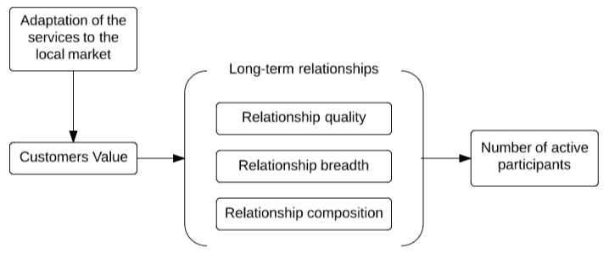
The conceptual model above shows the relationships between the main variables that would affect the expansion of Anglia Network Europe in Ukraine. The expansion can be considered successful when the company increases the number of active participants in the target region. Thus, in this case the number of active participants is the dependent variable, referring to teachers and students that are involved in one of Anglia’s projects, summer schools or examinations.
The expansion of Anglia Network Europe in Ukraine starts with meetings with the principals of the local schools in the form of focus groups. This method of data collection provides insight into the needs, wants and interests of the customers. According to which the company will adapt its existing services in terms of price, location and time, for example. Different schools have different requirements and capabilities. Therefore, it is important to address their needs individually. Personal approach helps to identify key changes that need to be made in order to create or increase customers’ value. The data from focus groups will be complemented with qualitative data from questionnaires that will show the perspective of students on Anglia activities.
Focus group interviews and questionnaires were not included into the conceptual model, as they are not a variable, but a mean of obtaining crucial data that will be used to affect the independent variable of the conceptual model, adaptation of the services to the local market.
Increasing customer value will not only make Anglia services more attractive, but also initiate the establishment of long-term relationships. Providing concessions and adapting the services to each school individually, will form reciprocity norms between the parties. As it is explained in the theory, mutual understanding and willingness to cooperate will also build trust. Together with commitment that will arise from the first cooperation agreements, this will result in active and profitable collaboration during considerable period of time.
Additionally, the theory of relationship marketing implies the formation of interpersonal bonds between organisations. This means that during projects, employees from Anglia will engage and work with the Ukrainian teachers and students. Consequently, relational bonds will be formed, that will help to allocate new profit-enhancing opportunities and withstand disagreements, if such arise.
Last part of relationship marketing, relationship composition, refers to the ability of a representative or a contact person to take important decisions regarding adaptations and compromises. Apparently, an authorised person can better understand the capabilities of the company to make these adaptations. Moreover, such person can easily evaluate possible options and assume the outcomes of each decision to ensure profitable cooperation with particular schools. In this case, profitability does not mean financial success, but also a possibility for Anglia to promote itself and increase brand awareness.
Ultimately, customer value and long-term relationship are a mediator variable that would influence the number of active participant and lead to the successful expansion in Ukraine. Adaptation of the services to the local market is the independent variable and a major influence to the research objective by the means of creating customers’ value and establishing durable relationships.
The following null hypothesis is formulated according to the conceptual model presented at the beginning of this section:
Adaptation of Anglia services to the local market has no effect on the number of active participants.

Proposed Solution
The main aim of this report is to determine the factors that affect the successful expansion of Anglia Network Europe in the Ukrainian market. During desk research, it was defined that, Anglia is a provider of soft-services. Together with unique layout of the network, this makes the relationships between the company and customers extremely important. Therefore, relationship marketing was determined as a main strategy for expansion in Ukraine.
Crucial part of building long-term relationship with customers is to understand their needs, wants and capabilities. To trigger the relationships with schools, Anglia will use available contacts to arrange the first meeting between organisations. This means that the existing professional or personal interorganisational connections will form a basis for cooperation. In case of unavailability of such connections, Anglia can approach schools directly or through intermediate party, such as the local Ministry of Education. The pursued goal is to arrange a meeting, where representatives from both sides can explain their aims and expectations from future cooperation. Moreover, such meetings help to allocate critical aspects that creates value for the customers.
A person of high authority needs to join these meetings in order to fulfil a crucial part of relationship marketing strategy, namely relationship composition. Live conversation with customers and immediate feedback provides Anglia with better insight into the schools’ demand. High flexibility of services of the company allows making certain adaptation to meet customers’ expectation, consequently increasing customers’ value. All of the meetings are organised in form of focus groups and involve teachers, principals into a structured conversation. The qualitative data will help to improve the future approach that will be used to contact schools in other cities of the targeted area.
In addition, Anglia Network Europe should also obtain quantitative data that will show different perspective. For this use, a questionnaire was designed (10.1 Appendix #1: Questionnaire), to provide the research with empirical proof that students are interested and willing to participate in Anglia activates. Anglia should ask schools to organise meetings with students, where representative can explain in details the company activities. After the presentation, students receive questionnaire to fill in. The results will display students’ preferences, motives and attitude toward English education.

5. Methodology
The findings of this paper are based on both primary and secondary research. The combination of these two elements would lead to more comprehensive understanding of the central problem, namely the expansion of Anglia Network Europe in Ukraine. Moreover, the adoption of several different approaches would eliminate the disadvantages of each separate method and thus increase the reliability and validity of the final results.
Desk research was the first step to acquiring enough information about the Ukrainian educational system, schools, and relevant background theories prior contacting and visiting the country. This phase of the research is crucial for preparing a detailed plan of action and outlining the most relevant questions and methods. The sources considered include scientific articles, official reports, books, online newspapers such as ‘Kyiv Post’, and Ukrainian educational websites such as ‘Osvita’. Based on the results of the desk research, the questionnaire, given to the students in Ukraine, was formulated, together with the school presentations and the focus group composition.
The second step of the research was the primary data collection during school visitation in Uzhorod, Ukraine. Prior to departure, Anglia was looking for new ways to arrange appointments with schools in the city, due to the lack of responses on the emails (82 schools in L’viv, 30 in Ivano-Frankivsk, 25 in Uzhorod) sent to the schools. Hence, the researcher consulted the Department of Education of Uzhorod and their contact person Olena Prits. Eventually, in total three schools were selected: two secondary schools specializing in English education and one regular secondary school. During the meetings, focus groups were conducted in order to gain more insight into the Ukrainian educational system, school requirements, and demands.
Focus group is a method for qualitative data collection based on listening and learning from a participants’ discussion, focused on a particular topic (Puget Sound Consortium for Manufacturing Excellenc, 2005). The reason for choosing this method is, as explained above, to gain more insight into the Ukrainian market, raise the awareness about Anglia and ask for principals’ and teachers’ opinions about Anglia services. The focus group is semi-structured, following a predesigned plan, which is presented below.

1. Anglia Network Europe brief explanation of services and company’s mission.
2. Summer schools – description of current schools, opportunities for schools in Ukraine, possibilities for changes: Teachers will be asked to express their opinion about the summer schools and its suitability to the Ukrainian market that Anglia Network Europe provides.
3. International projects (as described for summer schools)
4. Examination (as described for summer schools)
5. Ways to approach other schools – suggestions from the principals

Ultimately, three focus groups were conducted, one in each school. During each meeting the principal of the institution was present together with two or three English teachers. Additionally, a project coordinator with previous experience in organizing international programmes joined us in one of the schools. One moderator, Illya Kaynov, who had the role of translator as well, led the discussion. Arnold Augustijn, director of Anglia Network Europe, joined the discussion as a person of great authority and professional competence. As described in the conceptual model, when building a long-term relationship between two parties, the presence of such person, who is able to make adequate decisions regarding the future cooperation, is a necessity. In the model, this element called ‘relationship composition’. During the meetings, Arnold Augustijn addressed principals’ inquiries and requirements, sought compromises and came to an agreement. The results from the meetings will be discussed in more detail in the analysis section; while the coding of the focus groups can be found in appendix three.
The only disadvantage of the focus group is that it shows only the perspective of the teachers, but not of the students themselves. Therefore, in order to gain knowledge about the motivation of Ukrainian students to participate in Anglia’s projects, summer schools and exams, a questionnaire has been designed. It encompasses all essential elements that need to be considered; for example, whether the students want to study abroad, their opinion about the importance of English globally and personally; and levels of interest in Anglia activities.
Questionnaires are a quantitative research method, which provide a rather inexpensive and quick way to obtain large amounts of information from a large sample of people (McLeod, 2014). Moreover, this method eliminates bias from the side of the researcher or other external influences, unlike interviews, for example. The questionnaire, designed for this research, consists of close-ended questions, because they are easier to process and less time-consuming. More specifically, it includes multiple-choice, and Likert scale questions. Multiple-choice questions aim to analyse the motivation of the students to study abroad, the best way to learn English according to them or a possible reason for them to participate in Anglia activities. The Likert model, on the other hand, is focused on students’ opinion about the importance of English for them personally and globally. The findings are processed using IBM SPSS.
The complete questionnaire and processed results can be found in appendix one and two, respectively; while the overall results will be further analysed in the following chapter.

5.1 Sampling
The sample chosen for this research can be defined as a convenience non-probability sample. This means that the sample is simply selected according to its availability and accessibility (Bryman, 2012). In the case of Ukraine, due to the absence of response on emails, the three schools we eventually contacted were the only ones, who showed interest in the company and agreed to have a meeting at that time. Likewise, five groups of students, from 8th (48.4%), 9th (28.6%) and 10th (23.1%) grade, were chosen to participate in the questionnaire. Altogether, 91 students have participated in the questionnaire; which represents the absolute sample size. According to various academics (Bryman, 2012; Field, 2013) an absolute sample size larger than 30, would be large enough to be normally distributed and be considered reliable.
As Bryman (2012) suggests, the problem with non-probability sampling is that the findings cannot be generalized to the whole population (Bryman, 2012). However, they can be applied to the theoretical population of this research, namely the schools in the Western regions of Ukraine. Therefore, the results from this study can be applied in the future for the other two Ukrainian cities, L’viv and Ivano-Frankivsk. The reason for choosing these cities in particular is the higher diversity and quality of educational institutions, which enables Anglia to choose the most suitable and profitable ones.

Analysis
As already mentioned, altogether 91 students have participated in the questionnaire. The age group varies between the range of 13 and 16 years old. Students are attending 8th (48.4%), 9th (28.6%) and 10th (23.1%) grade. The graphical representation of the results can be found in 10.2 Appendix #2: The results from the questionnaires section.
Surprisingly, 47% (43 out of 91) of the respondents have decided to study abroad after graduation from secondary school. Such students recognise the high importance of English, and based on a correlation analysis, are more likely to join Dutch summer schools and international projects. However, there was no significant relation between willingness to participate in Ukrainian summer school and studying abroad.
Large share of students admit the high importance of English language. Nevertheless, more of the pupils find English more important in the world (87%) rather than for them personally (66%).
According to the focus groups, teachers find Dutch summer schools are too expensive for Ukrainian students. Interviewees claim that schools receive numerous propositions for summer schools in Czech Republic, Slovakia and Poland, that are more affordable than Anglia ones. Regarding Ukrainian summer schools, teachers were positive, but counted on considerable price reduction. The principals are willing to charge the lowest cost possible for rent, accommodation and food. In return, they would like to receive a price reduction for Ukrainian students.
The results from the focus groups show that schools have a high interest in international projects. Teachers liked the idea that students would be able to practice English with foreigners. According to the questionnaire results, students who would like to take part in Anglia projects (67% of respondents) also show interest in other Anglia activities such as exams and summer schools. Moreover, international projects was the most attractive activity for Ukrainian students. Compare to exams and summer schools, with 30% and 55% of positive response rate, respectively, projects received in their favour 67% of answers. (10.2 Appendix #2: The results from the questionnaires)
In addition, teachers have shown interest in examinations. However, they claim that without recognition of Ministry of Education, no student will be motivated enough to take an exam. Currently recognised international language exams: IELTS, TOEFL, Cambridge English Language Assessment (FCI), and Pearson Test of English (PTE). Such recognition gives students a possibility to pass Anglia exam and use the certificate to skip National Graduation Exam. This fact adds value to the Anglia examination, as it provides students with opportunity to pass their final English exam and receive certificate that is linked to Common European Framework of Reference. According to the teachers, if Anglia receives recognition, they are willing to recommend Anglia examinations to students. The results from questionnaire show, that for those who decided to take an Anglia exam in 72.5% of cases the reason was self-evaluation. After this comes motive to impress parents (19.6%), teachers (3.9%) and friends (3.9%). According to half of the respondents, best way to learn English is to find English-speaking environment.
The last topic for the focus groups was concentrated on improving the approach for contacting and allocating new schools in Western Ukraine. According to the teachers, answers, email communication will not work with schools unless Anglia has already introduced itself beforehand. The best approach that they could recommend is to use connections of teachers in other schools. Another way is contacting schools personally or asking assistance at local Department of Education in order to make official visits.
Altogether, three agreements were made with schools during the visitations: 1) “Specialized school #3” - students from the Netherlands will join Ukrainian students during regular lesson. The school provides lowest cost for living arrangements and other expenses. In return, Ukrainian students will participate in one of the summer schools in August 2016 with decreased price. 2) “Linguistic Gymnasium” autumn school in October, which will be organised by Anglia at location of the school. Administrations of both schools provides free classrooms and decreased cost for other expenses, to reduce the final price for their students. 3) “Classic gymnasium” will participate in one of Anglia projects called High Five in November 2016. Additionally, the school requested a membership in Anglia Network.
The limitations will be further discussed in the 7.1 Limitations section.

Conclusion
Based on the data described in the analysis section of the research the following conclusions can be made. First, the administration of the schools and its students are acknowledged with the importance of English. They recognise the need of extra activities that strive to improve language skills. This fact forms a solid base for company to promote its services. Moreover, according to the questionnaire, a big share of students showed interest in continuing their education abroad. This raises the importance of English in the area even higher. Together with a market gap that was formed by absence of companies that provide similar English-related activities, this has create a high demand on Anglia services in the region.
Such a demand enables Anglia to look for the possibility to further access Ukrainian market. Nevertheless, in order to be able to address customers’ needs, the company need to understand them first. Regarding Anglia activities, schools have shown interest in all three of them, international projects, summer schools and examinations.
Second, international project is the most attractive part of Anglia activities. Teachers found the idea of international practice the most interesting and affordable for their students. The fact that Anglia Network connect 350 schools all over the Netherlands improves the perception of the projects in the eyes of teachers. These facts mean that during the promotion of Anglia services to other schools in Ukraine, the company should make an emphasis on the size of the network and introduce projects in the first place.
Due to the low income in Ukraine, compare to Netherlands, the price for Dutch summer school is extremely high for a regular Ukrainian family. This was proven during the focus-group interviews. In three cases teachers mentioned that schools receive numerous and more affordable propositions for summer schools from commercial organisations. In addition, long distance between the Netherlands and Ukraine leads to high transportation cost. All these factors, makes Dutch summer schools unaffordable for Ukrainian customers.
Nevertheless, the idea of organising such schools in Ukraine, at the location of the schools was warmly accepted. The results shows that schools indeed have different requirements. Change in time, content and price was requested. Administrations are willing to provide accommodation, food and classroom in order to decrease a price for their students. Anglia was prepared to make such adaptations in order to add value for its activities, consequently leading to establishment of long-term relationship. In this case, summer schools are the main adaptable service for Anglia that would help to increase trust and reciprocity norms.
Moreover, schools are also interested in examinations, but they do not recognize its value unless certificates are accepted by universities or by Ministry of Education of Ukraine. Such recognition would allow students to use Anglia certificate to enter a university and skip English graduation exam. The list of recognised exams is published every year from Ministry of Education. Contacting the Ministry of Education with relevant documentation will probably include Anglia examinations into the list. This will add value to the exams and provide students with a nationally approved product. In this case, teachers can and will recommend Anglia language assessment to students.
Nevertheless, Anglia Network Europe is willing to expand outside Uzhorod. During the focus groups participants mentioned that emails do not work for Ukrainian schools. That is why Anglia should approach schools personally, by directly introducing its activities to principals. Phone conversations can be acceptable, but it rather inefficient. Conversely, contacting local Department of Education, on the other hand, is an extremely useful method. Local authorities can find schools that are more likely to be interested in Anglia activities. This helps the expansion process, as it allows focusing on most perspective clients.
During the research, it was noticed that teachers in the Ukrainian schools possess sufficient English knowledge. This allow Anglia to arrange future meetings with other schools without involvement of interpreter.
To sum up, the result from the visits, three agreements with schools for projects and summer schools, indicates that the number of active participants will change at time of first activity in October 2015. Thus, adaptations of Anglia services is the main tool of creating customers’ value. Moreover, establishment of relationships by increasing customers’ value of services is a working approach that will support further expansion. At least one school have already requested membership. This fact together with appointed activities allow to assume the increase in number of active participants. Therefore, it can be concluded that null hypothesis was proven wrong: adaptations of the services to the local market have effect on the number of active participants. This allows answering the research question, factors that lead to the successful expansion of Anglia Network Europe in Ukraine are adaptation to the local market, creation of customers’ value and establishment of long-term relationships.

7.1 Limitations
The sample method that was used in the research was convenience non-probability sampling. Thus, the first limitation is a lack of probability sampling during quantitative research. Moreover, Anglia have only contacted schools that specialize on English education, therefore, if the company decide to contact non-specialized school results may be different.
During the validation stage of the research, personal contacts were used to arrange meetings with schools. It is important to mention that the researcher comes from the region where research was conducted. This fact may affect the results, because visits were organised by person who understands local language and possess deep knowledge of the local culture. The cultural aspects were not included in the research, as its affect was considered insignificant. Nevertheless, for further expansion including a person who speaks Ukrainian in visiting groups is favourable, but not necessary, as it may ease the communication process and avoid misunderstandings.

Recommendations
- Contact visited schools and confirm pre-agreed projects.
  - Confirm membership from Classic Gymnasium and their participation in High Five project.
  - Confirm and develop a plan, budget for autumn school in October 2015 with Linguistic Gymnasium.
  - Contact School #3 and discuss Ukrainian summer school in 2016, and reciprocal student exchange.
- Ask schools to provide information about main universities that are popular among students. Make an inquiry to the universities about validation of Anglia exams.
- Contact Ministry of Education to ask for the recognition of Anglia certificates.
- Continue the expansion of Anglia Network to the cities of L’viv and Ivano-Frankivsk using developed strategy.
- Find a contact person in the targeted regions in Ukraine, who would promote Anglia activities, work on expansion of the network and report on current developments in education sector.

Bibliography
Berry, L. (1983). Relationship Marketing. American Marketing Association. Chicago.
Bryman, A. (2012). Social Research Methods (4th ed). Oxford: Oxford University Press.
Erramilli, M. K. (1990). Entry Mode Choice in Service Industries. International Marketing Review.
Europe, A. N. (2013). Annual Report Anglia Network Europe. Roosendaal, Netherlands.
Gummesson, E. (2008). Total RElationship MArketing. Burlington: Elsevier Ltd.
Harker, J. (1999). Marketing Intelligence & Planning. Journal of Marketing Practice: Applied Marketing Science, Vol. 17 Iss: 1, pp.13 - 20.
Head, K. (2007). Elements of Multinational Strategy. Vancouver: Springer-Verlag Berlin Heidelberg.
Lewis, M. P. (2015). Ethnologue: Languages of the World, Eighteenth edition. Dallas, Texas, United States of America. Retrieved from http://www.ethnologue.com.
McLeod, S. (2014). Questionnaire. Research methods. Retrieved from http://www.simplypsychology.org/questionnaires.html
New Report Highlights Increasing Global Importance of the English Language. (2013, September). Retrieved from http://www.expatforum.com/britain/new-report-highlights-increasing-global-importance-of-the-english-language.html
Palmatier, R. W. (2008). Relationship marketing. Cambridge, Massachusetts: Marketing Science Institute.
Puget Sound Consortium for Manufacturing Excellenc. (2005). A guide for Planning, Organasing, and Managing Focus Groups. Retrieved from Puget Sound Consortium for Manufacturing excellence.
(2010). The World Factbook - Languages. Central Intelligence Agency 2010.
Ukraine Today: English language boost in Ukraine;. (2014, October). Retrieved from KyivPost: http://www.kyivpost.com/multimedia/video-2/ukraine-today-english-language-boost-in-ukraine-poroshenko-suggests-teaching-english-instead-of-russian-video-366984.html
В школах влітку відкриються мовні табори. (2014). Retrieved from Osvita: http://osvita.ua/school/46109/
Проект Концепції розвитку освіти України на період 2015–2025 років. (2014, October). Retrieved from Ministry of Education of Ukraine: http://www.prof.univ.kiev.ua/prof/home/2010-12-22-00-05-45/2-events/571--2015-2025-.html

Appendices

10.1 Appendix #1: Questionnaire
Based on the information you received about Anglia Network Europe, we ask you to fill in this questionnaire. This will help us to understand the pupils’ needs and define company`s fate in Ukraine. Near every answer there is words and sentences that help to extend your answer. Underline those parts that is more suitable for you, this will be counted separately from the main answer. Your opinion is extremely important for us.
○ – one answer; □ – several answers;

I am in ___ grade My age:___
Name of my school: _______________________________________________________________________
Number of English lessons per week: ____
I think that English language is extremely important in the modern world:
(5 – Totally agree, 1- completely disagree):
○ 1 ○ 2 ○ 3 ○ 4 ○ 5
I think that English will play important role in my life:
(5 – Totally agree, 1- completely disagree):
○ 1 ○ 2 ○ 3 ○ 4 ○ 5
I am planning to continue my study abroad:
- Yes ○ No ○ Did not decide yet
I think that the best way to learn English is:
- Private tutoring (additional lessons)
- Self-Education ( movies, books, TV-programs, video/audio lessons, pen friend)
- To study in English-speaking environment (summer schools/camps, traveling abroad)
- Other:________________
Underline your method.

I would like to take part in one of the summer schools that will take place in Netherlands:
- Yes (to study English, meet new friends, to visit the Netherlands, other______________________)
- No (too expensive, too far, other______________________________________)
- Cannot decide yet (need more info, need to talk to parents, other_________)
Underline the reason.
I would like to take part in one of the summer schools that will take place in Ukraine:
- Yes ○ No ○ Cannot decide yet
I would like to join one of the international projects with foreign schools:
- Yes (want to meet new friends, practice English language, to know something new)
- No (I am not interested, don`t have enough time, other_____________________)
- Cannot decide (need more information, other________________________)
Underline the reason.
I would like to register for the exam:
- Yes ○ No ○ Cannot decide yet
If you answered “yes” on previous question, indicate below how you will use the certificate:
- To impress parents
- To impress my friends
- To impress my teacher
- To define my level (self-evaluation)
- To practice before other exam (which exactly? _________________________________)
My comments, remarks and impressions about the presentation (not obligatory): ________________________________________________________________________________________________________________________________________________________________________________________________________________________________________________________________________________________________________________________________________________________________

Fill in your email, if you want to receive a newsletter from Anglia Network Europe (not obligatory): ___________________________________________________

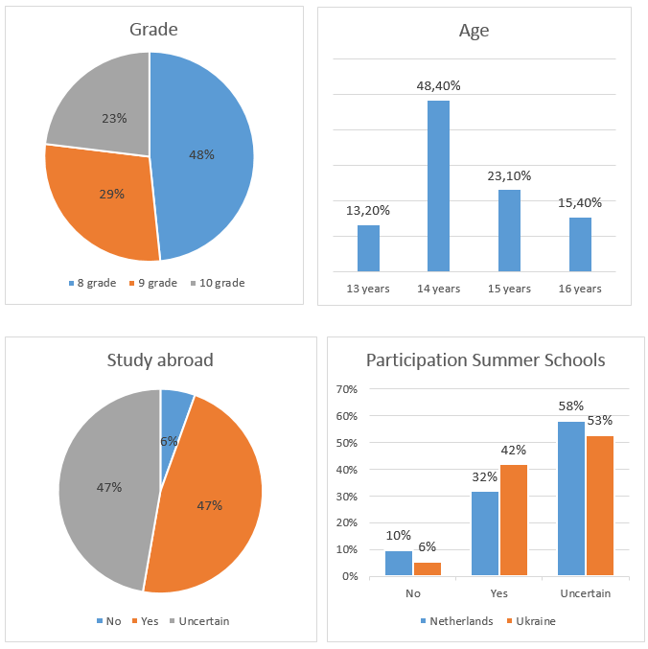
10.2 Appendix #2: The results from the questionnaires

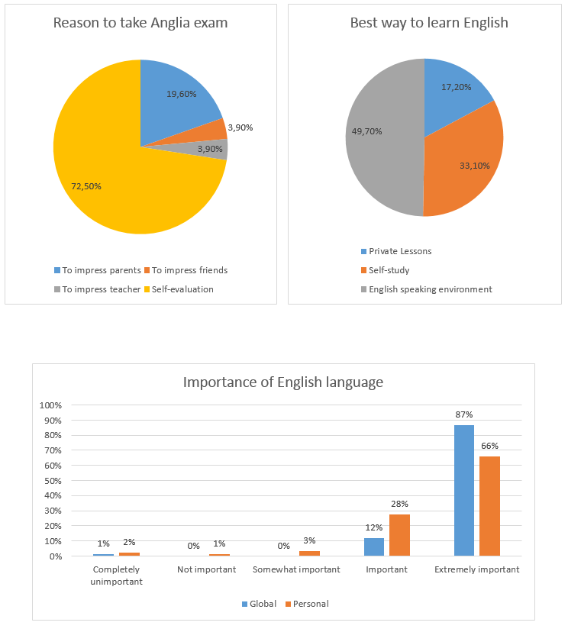

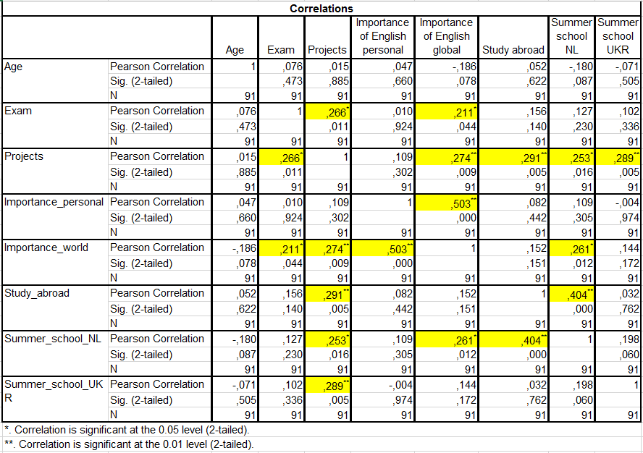
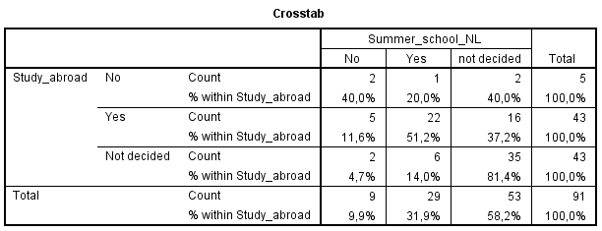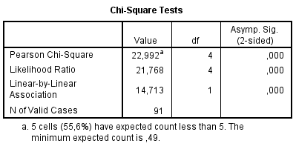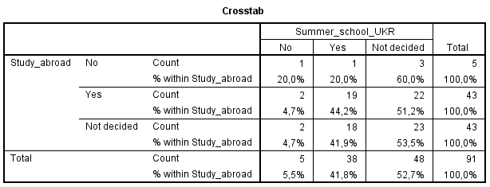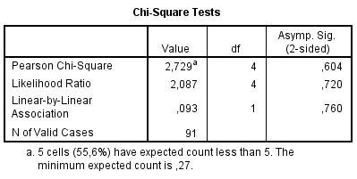
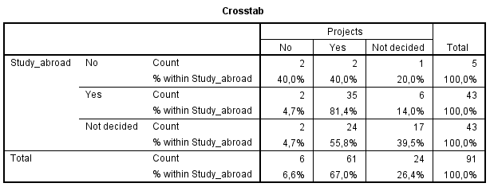
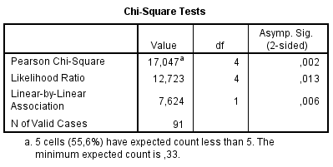

10.3 Appendix #3: Coding of the Focus Groups
Focused Coding | Open Coding | Data
Anglia Services | Summer Schools | - High price of Dutch summer schools  - Reciprocal students exchange in order to decrease cost for Ukrainian students  - Autumn schools (change in date for summer schools)  - High competition for summer schools (schools receive numerous offers for more affordable summer schools)
 | Projects | - High interest in projects  - One of the schools is willing to become a member in order to participate in projects  - Funds for the membership will be provided from students
 | Examinations | - Accreditation and validity of the exam is extremely important  - Self-evaluation is important but not enough for students to take an exam  - Price for exam is acceptable  - One of the school would like to substitute their graduation exam with Anglia exam, when Anglia examinations receive accreditation  - Schools are willing to recommend Anglia examinations, if they were accepted by universities or approved by Ministry of Education of Ukraine
 | Suggestions | - Emails does not work – schools receive numerous deals from commercial organizations  - Best way to approach schools is personal visits  - It is favourable to have a contact in targeted school

